## <!—Lab 1: Basic Structure of html document-->

<html>

<head>

<title>

Put the title of document here.

</title>

</head>

<body>

Put the document content here.

</body>

</html>

## Output

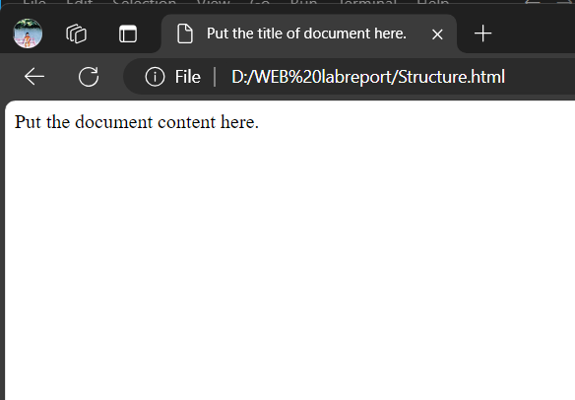

## <!--Lab 2: Working with meta tag-->

<html>

<head>

<meta name="author" content=“Pramisha">

<meta name="revised" content=“PramishaPaudel.6/10/2024">

<meta name="generator" content="HTML">

<meta name="description" content="HTML examples">

<meta name="keywords" content="HTML, DHTML, CSS, JavaScript, PHP">

</head>

<body>

<p>

The meta attributes of this document identify the author and the editor software.

<p>

The meta attributes of this document describe the document and its keywords.

</p>

</p>

</body>

</html>

## Output

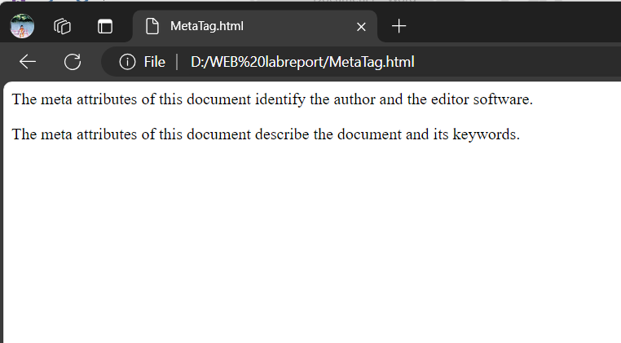

## <!--Lab 3: Redirect site to the changed address-->

<html>

<head>

<meta http-equiv="Refresh" content="5;url=index.html" >

</head>

<body>

<p>

Sorry! We have moved! The new URL is:

<a href="index.html">http://www.aniwave.to</a>

</p>

<p>

You will be redirected to the new address in five seconds.

</p>

<p>

If you see this message for more than 5 seconds, please click on the link above!

</p>

</body>

</html>

## Output

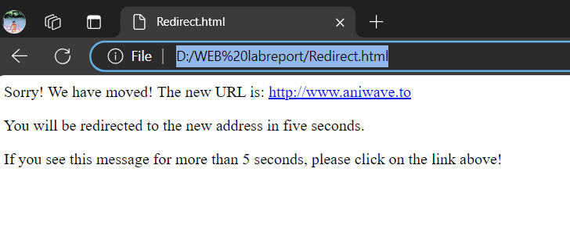

## <!--Lab 4: Working with heading tag-->

<html>

<head>

<title> Heading Tag Demonstration </title>

</head>

<body>

<h1>This is a heading 1</h1>

<h2 >This is a heading 2</h2>

<h3>This is a heading 3</h3>

<h4 >This is a heading 4</h4>

<h5>This is a heading 5</h5>

<h6>This is a heading 6</h6>

</body>

</html>

## Output

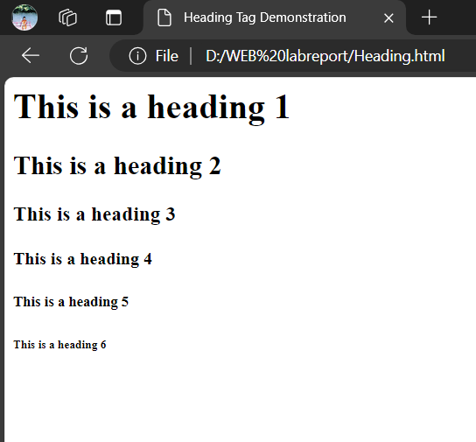

## <!--Lab 5: Working with paragraph and break tag-->

<html lang="en">

<head>

<title>Document</title>

</head>

<body>

<p>This is paragraph</p>

<p>This is another Paragraph</p>

<p>This is a paragraph with <br>break tag </p>

</body>

</html>

## Output

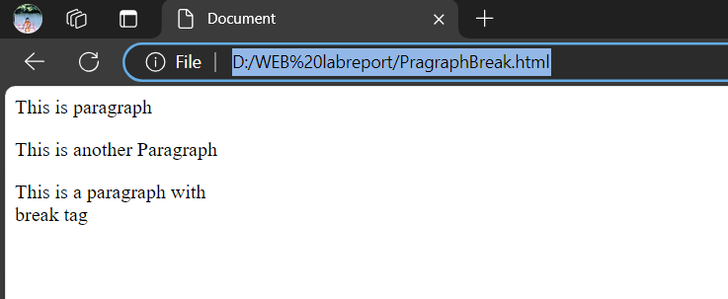

## <!--Lab 6: Working with Text formatting tags -->

<html>

<head>

<title>Text formatting tags</title>

</head>

<body>

<b>This text is bold</b> <br>

<strong>This text is strong</strong> <br>

<big>This text is big</big> <br>

<em>This text is emphasized</em> <br>

<i>This text is italic</i> <br>

<small>This text is small</small> <br>

This text contains<sub>subscript</sub> <br>

This text contains<sup>superscript</sup><br>

<strike>Striked text</strike><br>

<u>Underline</u><br>

</body>

</html>

## Output

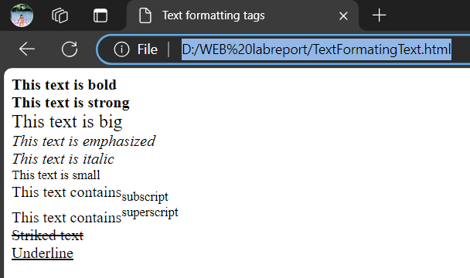

## <!--Lab 7: Working with Background and font tag-->

<html>

<head>

<title>Background</title>

</head>

<body background="luffy.jpg">

<font face = "arial" size="2" color="blue">

Pramisha Paudel is written in Arial font.

</font> <br>

<font face="Times" size="7" color="magenta">

This is Times New Roman Font.

</font> <br>

</body>

</html>

## Output

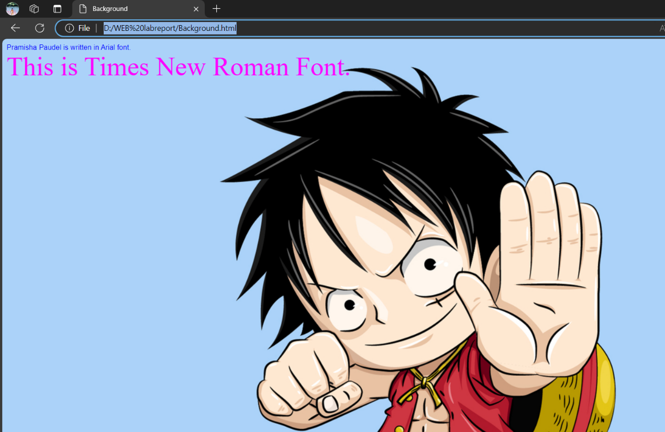

## <!--Lab 8: Formatted output-->

<html>

<head>

<title>Formatted Output</title>

</head>

<body>

<pre>

This is

preformatted text.

It preserves both spaces

and line breaks.

</pre>

<p><tt>The pre tag is good for displaying</tt> computer

code:</p>

</body>

</html>

## Output

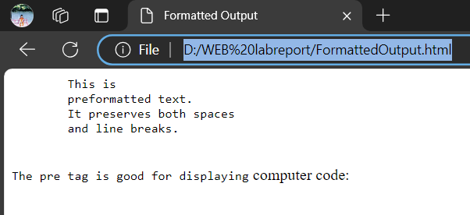

## <!--Lab 9: Working with image tag-->

<html>

<body>

<p><strong>Float the image to the right:</strong></p>

<img src="luffy.jpg" style="float:right;width:42px; height:42px;">

A paragraph with a floating image. A paragraph with a floating image. A paragraph with a floating image.

<p><strong>Float the image to the left:</strong></p>

<img src="luffy.jpg" style="float:left;width:42px;height:42px;">

A paragraph with a floating image. A paragraph with a floating image. A paragraph with a floating image.

</p>

</body>

</html>

## Output

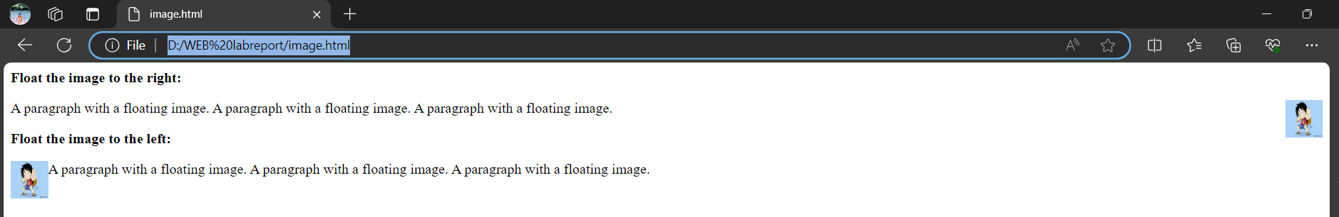

## <!--Lab 10: Working with imagemaps-->

<!DOCTYPE html>

<html lang="en">

<head>

<title>image</title>

</head>

<body>

<img src="trianglecirclesquare.png" alt="triangle circle square" height="550" width="1550" usemap="#mymap">

<map name="mymap">

<area shape="circle" coords="2012,395,273" title="Circle" href="https://byjus.com/maths/circles/">

<area shape="rect" coords="198,105,745,660" title="Rectangle" href="https://www.cuemath.com/geometry/rectangle/">

<area shape="poly" coords="1240,116,974,662,1516,666" title="triangle" href="https://byjus.com/maths/triangles/">

</map>

</body>

</html>

## Output

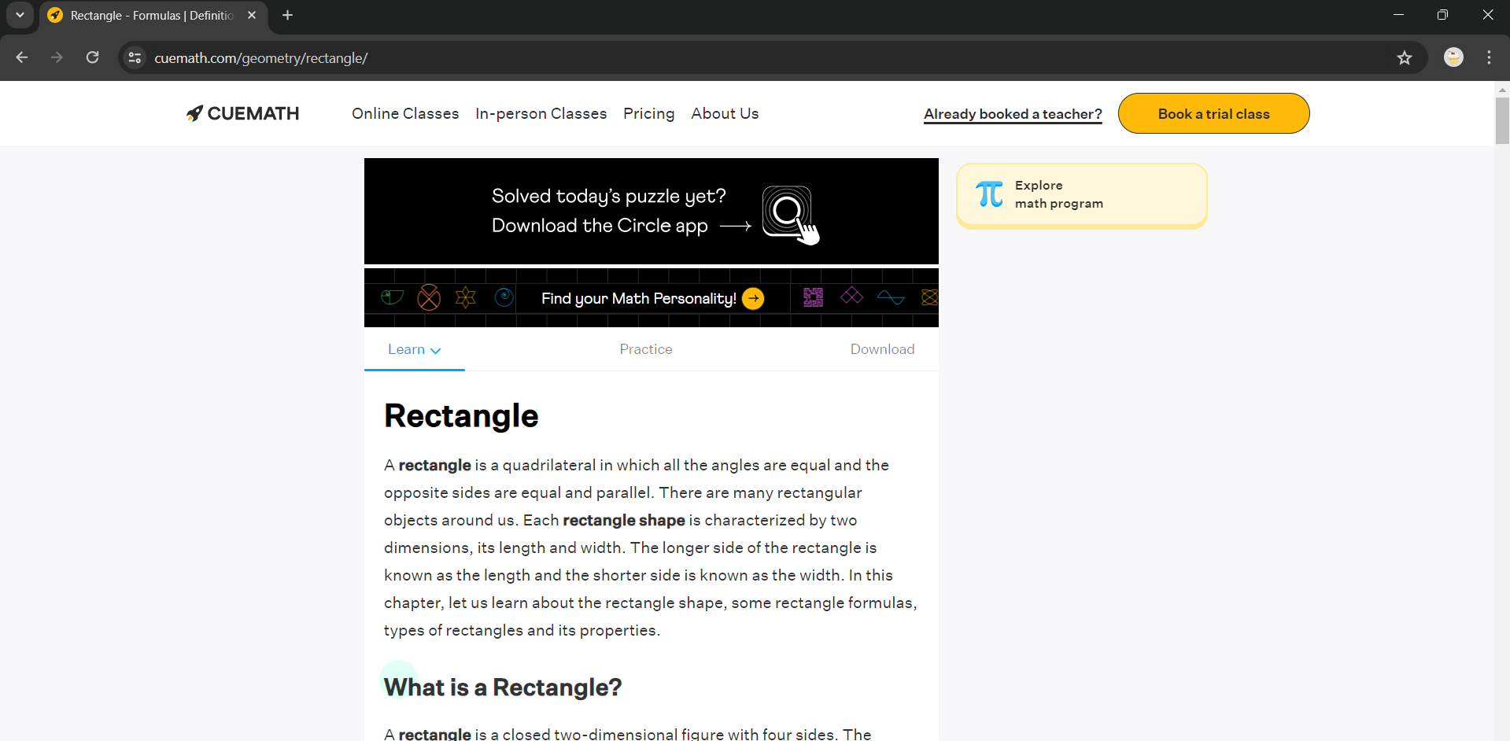

## <!--Lab 11:Using Hyperlink (anchor within page)-->

<html>

<body>

<p>

<a href="#C12">Jump to Chapter 12.</a>

</p>

<a name="C1"><h2>Chapter 1</h2></a>

<p>This chapter explains ba bla bla</p>

<h2>Chapter 2</h2>

<p>This chapter explains ba bla bla</p>

<h2>Chapter 3</h2>

<p>This chapter explains ba bla bla</p>

<h2>Chapter 4</h2>

<p>This chapter explains ba bla bla</p>

<h2>Chapter 5</h2>

<p>This chapter explains ba bla bla</p>

<h2>Chapter 6</h2>

<p>This chapter explains ba bla bla</p>

<h2>Chapter 7</h2>

<p>This chapter explains ba bla bla</p>

<br>

<h2>Chapter 8 </h2></a>

<p>This chapter explains ba bla bla</p>

<h2>Chapter 9</h2>

<p>This chapter explains ba bla bla</p>

<h2>Chapter 10</h2>

<p>This chapter explains ba bla bla</p>

<h2>Chapter 11</h2>

<p>This chapter explains ba bla bla</p>

<a name="C12"><h2>Chapter 12 <a href="#C1">Go to</a></h2></a>

<p>This chapter explains ba bla bla</p>

<h2>Chapter 13</h2>

<p>This chapter explains ba bla bla</p>

<h2>Chapter 14</h2>

<p>This chapter explains ba bla bla</p>

<h2>Chapter 15</h2>

<p>This chapter explains ba bla bla</p>

</body>

</html>

## Output

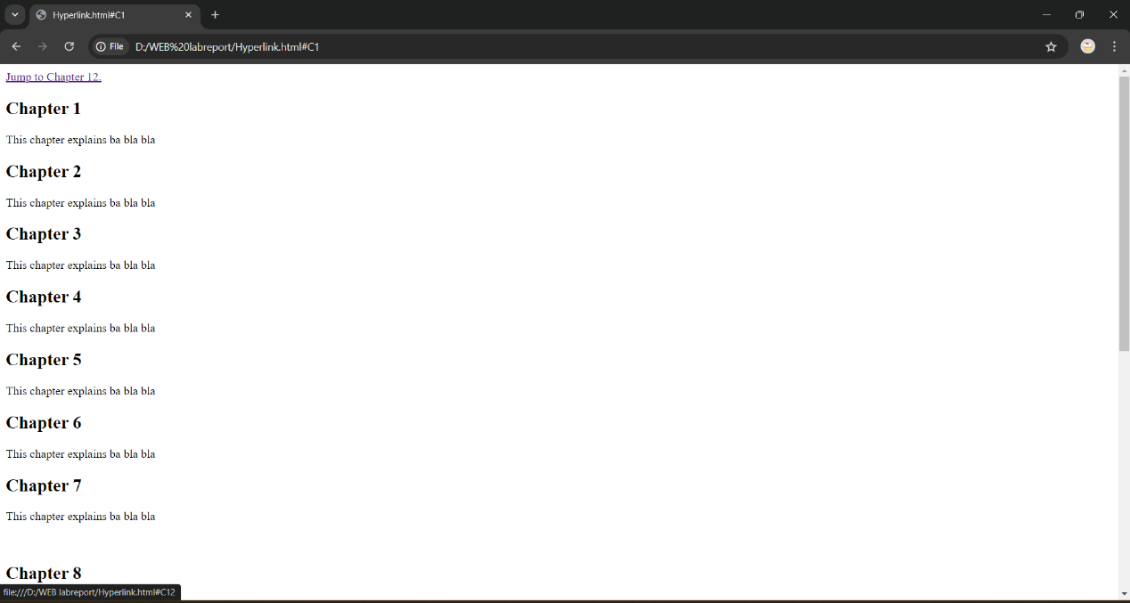

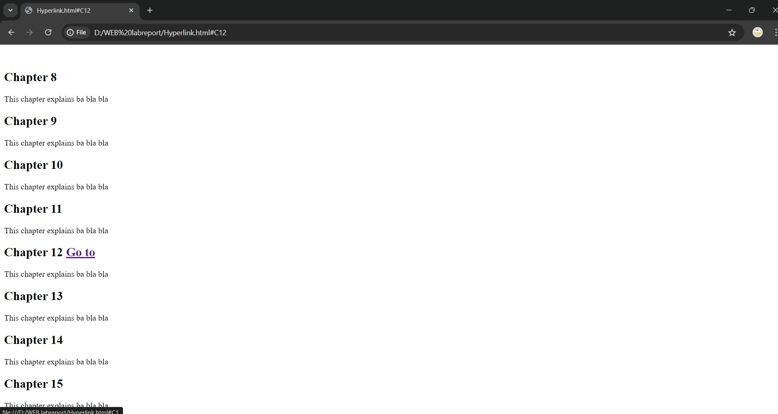

## <!--Lab 12:Using Hyperlink -->

<html>

<body>

<a href="Hyperlink.html" target="_blank">Hyperlink Page </a>

<p>

If you set the target attribute of a link to "_blank", the link will open

in a new window.

</p>

</body>

</html>

## Output

## 

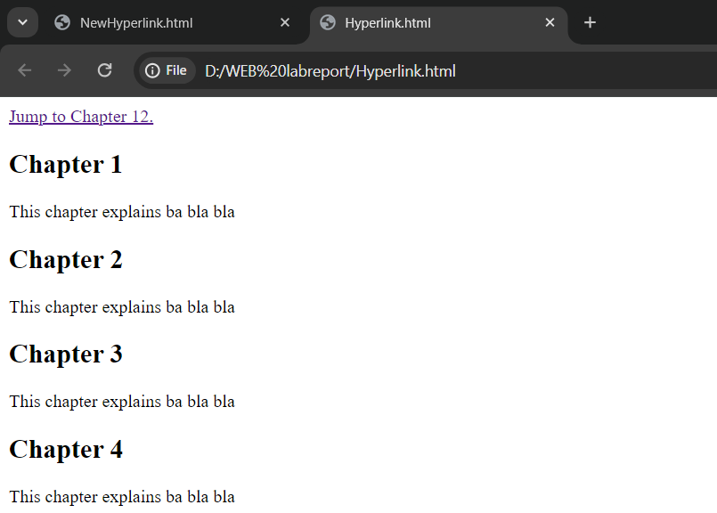

## <!--Lab 13: Working with List -->

<html>

<body>

<h2>An ordered HTML list</h2>

<ol>

<li>Coffee</li>

<li>Tea</li>

<li>Milk</li>

</ol>

<h2>An unordered HTML list</h2>

<ul>

<li>Coffee</li>

<li>Tea</li>

<li>Milk</li>

</ul>

<h2>A Description List</h2>

<dl>

<dt>Coffee</dt>

<dd>- black hot drink</dd>

<dt>Milk</dt>

<dd>- white cold drink</dd>

</dl>

</body>

</html>

## Output

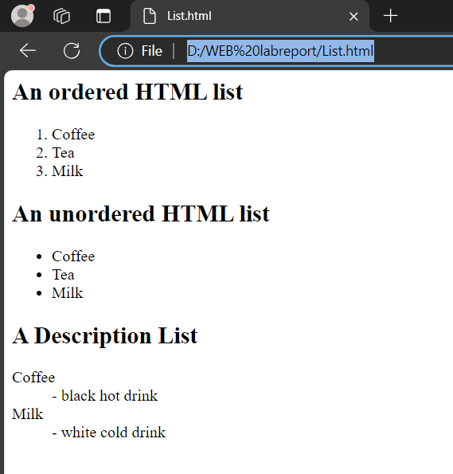

## <!--Lab 14: Working with marquee tag -->

<html lang="en">

<head>

<meta charset="UTF-8">

<meta name="viewport" content="width=device-width, initial-scale=1.0">

<title>Example for HTML Marquee Tag</title>

</head>

<body>

<marquee width="40%" direction="up" height="200px" behavior="scroll" scrollamount="3">

Welcome to Our Website! Stay Updated with the Latest News and Offers. Check Back Often for More Updates!

</marquee>

</body>

</html>

## Output

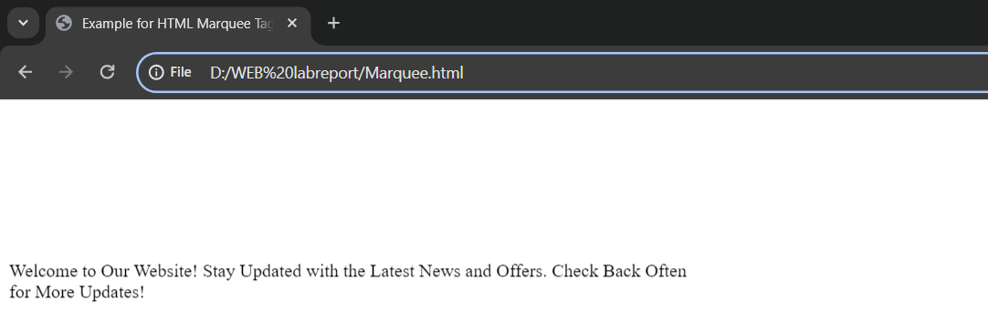

## <!--Lab 15: Working with abbr, acronym, address & dfn tag-->

<html>

<body>

<p>The <abbr title="World Health Organization">WHO</abbr> was founded in 1948.</p>

The head office is located at :

<address>

Geneva, Switzerland

</address>

According to WHO:

<dfn>

Health is a state of complete physical, mental and social well-being and not merely the absence of disease or infirmity.

</dfn><br>

<acronym title="WHO">World Health Organization</acronym>

</body>

</html>

## Output

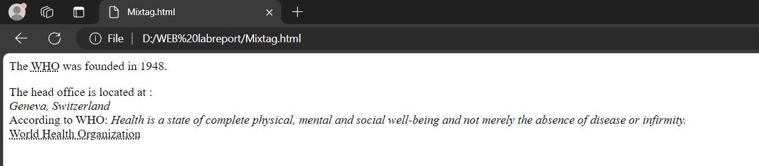

## <!--Lab 16: Creating a table-->

<!DOCTYPE html>

<html lang="en">

<head>

<title>Table</title>

<style>

table{

border-collapse: collapse;

border-style: solid;

}

</style>

</head>

<body>

<Table border="2">

<tr>

<td colspan="2">Phone:01-545454545 Address:Kirtipur,Kathmandu</td>

<td align="right"> Social Media List(link)</td>

</tr>

<tr>

<td colspan="3">

Logo[Image] Website Name[h1]

</td>

</tr>

<tr>

<td colspan="3">Menu</td>

</tr>

<tr>

<td>

<b>Recent Posts</b>

<ul>

<u>

<li>Post1 title</li>

<li>Post2 title</li>

<li>Post3 title</li>

<li>Post4 title</li>

<li>Post5 title</li>

</u>

</ul>

</td>

<td colspan="2" align="center">[Image] <br>Description............(paragraph)</td>

</tr>

<tr>

<td colspan="3" align="center">Copyright &COPY; Your site name</td>

</tr>

</Table>

</body>

</html>

## Output

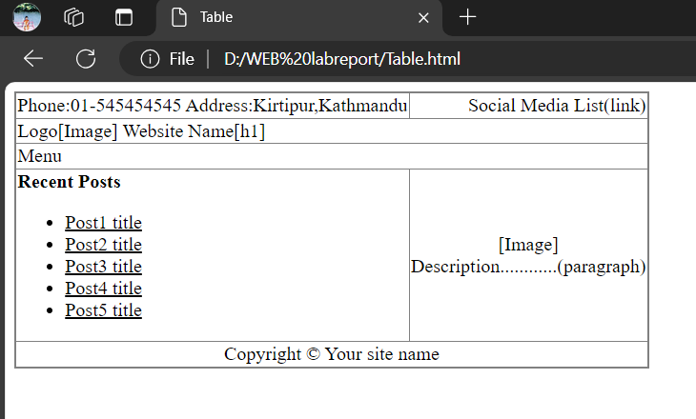

## <!--Lab 17: Creating a form -->

<!DOCTYPE html>

<html lang="en">

<head>

<title>Form</title>

</head>

<body>

<Form>

<h3>Fill the following Form</h3>

<label for="Name">Name:</label>

<input type="text" name="FullName" id="Name" required><br><br>

<label for="psw">Password:</label>

<input type="password" name="password" id="psw"><br><br>

<label for="email">Email:</label>

<input type="email" id="email" name="email"><br><br>

<label for="no">Phone Number:</label>

<input type="tel" min="1000000000" max="9999999999" id="no" name="number"><br><br>

<label for="sex">Sex:</label>

<input type="radio" id="male" name="sex">

<label for="male">Male</label>

<input type="radio" id="female" name="sex">

<label for="female">Female</label><br><br>

<label for="country">Country:</label>

<select id="country" name="Country" >

<option value="" selected disabled>Select an option</option>

<option value="nepal">Nepal</option>

<option value="india">India</option>

<option value="china">china</option>

<option value="pakistan">Pakistan</option>

</select><br><br>

<label for="color">Favourite Color:</label>

<input type="color" id="color" name="color">

<input type="button" id="ok" value="select"><br><br>

<label for="message">Message:</label><br>

<textarea name="message" id="message" rows="3"cols="27"></textarea><br><br>

<input type="checkbox" name="subscribe" id="subs">

<label for="subs">Subscribe?</label><br><br>

<input type="submit">

</Form>

</body>

</html>

## Output

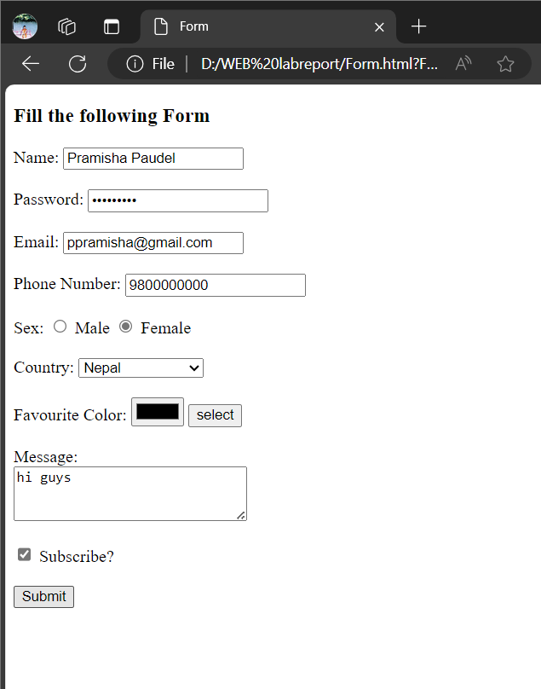

## CSS

## /*Lab 1: External Style Sheet*/

## Html file

<html>

<head>

<title>Style sheets by LINKING</title>

<link rel="stylesheet" type="text/css" href="mystyle.css">

</head>

<body>

<h1>I am formatted with a linked style sheet</h1>

<p>This is paragraph !!</p>

</body>

</html>

## CSS file

/*mystyle.css*/

h1{

font-weight:normal;

font-size:16pt;

color:red

}

p {

font-weight:bold;

text-align:center;

font-family:"sans serif";

color:blue

}

## Output

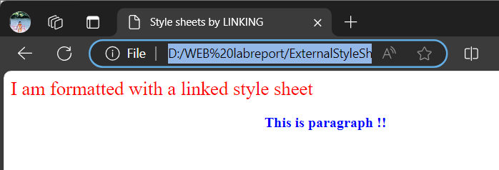

## /*Lab 2: Internal Style Sheet*/

<html>

<head>

<style>

h1 {color: red ; text-align:center}

h3 {color: blue; text-align:right}

</style>

</head>

<body>

<h1>This is header 1</h1>

<h3>This is header 3</h3>

</body>

</html>

## Output

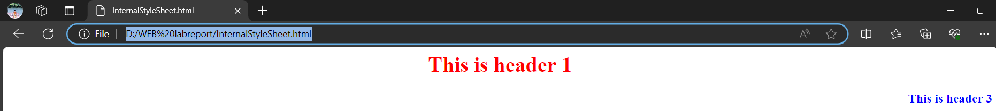

## /*Lab 3: Inline Style Sheet*/

<html>

<head>

<title>Style sheets</title>

</head>

<body>

<h1 style="color:blue;text-align:center;">This is a heading</h1>

<p style="color:red;">This is a paragraph.</p>

<a href=”https:\\www.google.com" style="text-decoration:none">

Makes a link without underlined</a>

</body>

</html>

## Output

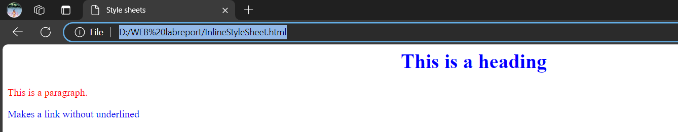

## /*Lab 4: Positioning*/

<html>

<head>

<title>abz-position</title>

<style>

h1.x {

z-index: -1;

position:relative;

left:10px;

top:10px;

color: red;

}

h2.y{

z-index:-2;

position:absolute;

left:10px ;

top:30px;

}

</style>

</head>

<body>

<h1 class="x">This is a Heading</h1>

<h2 class="y">This is a Heading</h2>

</body>

</html>

## Output

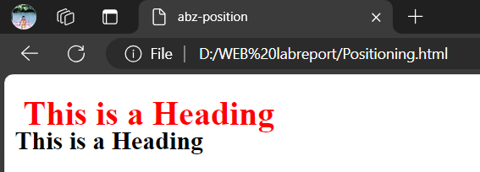

## /*Lab 5: Visibility*/

<html>

<head>

<style>

h1.one { visibility: visible; }

h1.two { visibility: hidden; }

</style>

</head>

<body>

<h1 class="one">Heading One</h1>

<h1 class="two">Heading Two</h1>

<p>Where is Heading Two?</p>

</body>

</html>

## Output

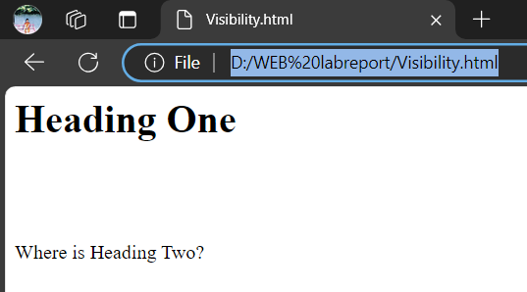

## /*Lab 6: Z-index*/

<!--z-index.html-->

<html>

    <head>

    <style>

        img.x{

            position:absolute;

            left:50px;

            top:60px;

            z-index:-1;

        }

    </style>

    </head>

    <body>

        <h1>This is a Heading</h1>

        <img class="x" src="luffy.jpg" height="180">

        <p>Default z-index is 0. Z-index -1 has lower priority.</p>

    </body>

</html>

## Output

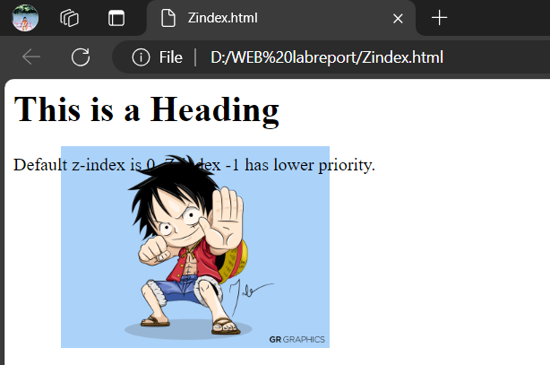

## /*Lab 7: Background using CSS with no repetition*/

<html>

    <head>

        <style type="text/css">

            body {

                background: #00ff00;

                background-image: url("luffy.jpg");

                background-repeat: no-repeat;

                background-position: center;

            }

        </style>

    </head>

    <body>

        <p><b>Note:</b> I am a Monkey D. Luffy!!!!!</p>

    </body>

</html>

## Output

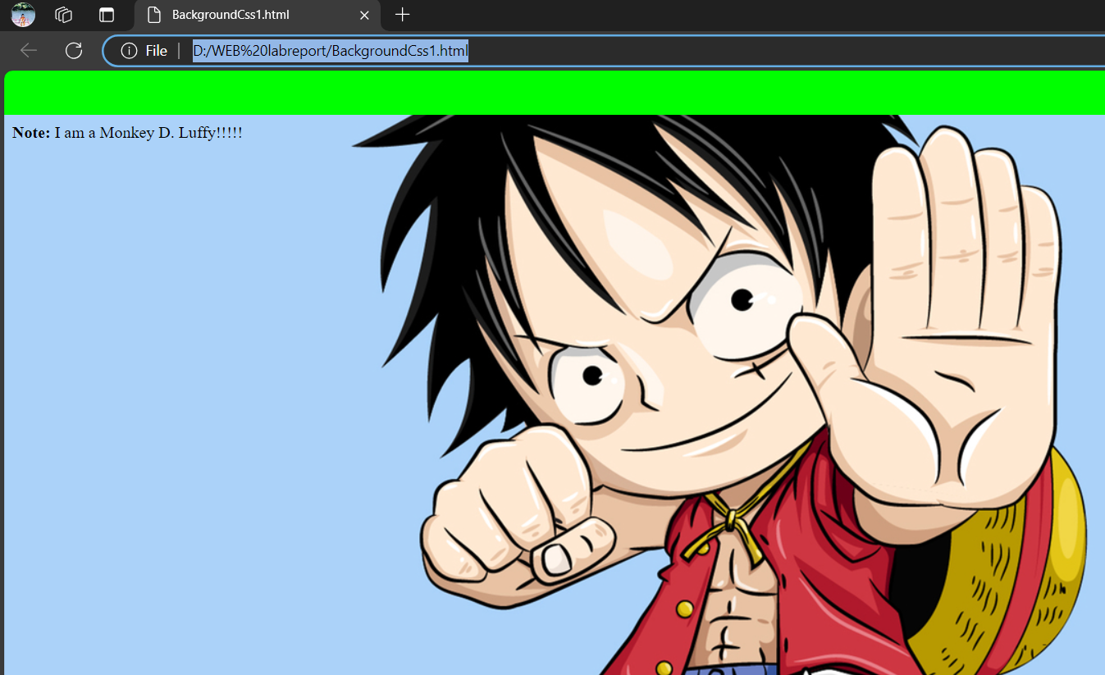

## /*Lab 8: Background using CSS where image don’t move*/

<!--background_no_move.htm-->

<html>

    <head>

        <style>

            body {

                background-attachment: fixed;

                background-image: url("luffy.jpg");

                background-repeat: no-repeat;

            }

        </style>

    </head>

    <body>

        <p>Scroll the page and see what happens</p>

        <br><br><br><br><br><br><br>

        <p>Scroll the page and see what happens</p>

        <br><br><br><br><br><br><br>

        <p>Scroll the page and see what happens</p>

        <br><br><br><br><br><br><br>

        <p>Scroll the page and see what happens</p>

        <br><br><br><br><br><br><br>

        <p>Scroll the page and see what happens</p>

        <br><br><br><br><br><br><br>

        <p>Scroll the page and see what happens</p>

        <br><br><br><br><br><br><br>

        <p>Scroll the page and see what happens</p>

        <br><br><br><br><br><br><br>

    </body>

</html>

## Output



## /*Lab 9: Set background color for an element */

<html>

    <head>

        <style type="text/css">

            body {background-color: yellow;}

            h1 {background-color: #00ff00; width: 250px;}

            h2 {background-color: transparent;}

            p {background-color: rgb(250,0,255); width: 400px;}

        </style>

    </head>

    <body>

        <h1>This is header 1</h1>

        <h2>This is header 2</h2>

        <p>This is a paragraph</p>

    </body>

</html>

## Output

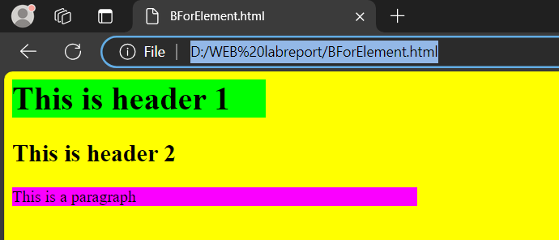

## /*Lab 10:CSS text properties */

<html>

    <head>

        <style type="text/css">

            h1 {color: red;}

            h2 {direction: rtl;}

            h3 {letter-spacing: -3px; color: #dda0dd;}

            h4 {letter-spacing: 0.5cm; color: rgb(0,0,255);}

            h5{text-align: center; text-decoration: line-through;}

            .indent {text-indent: 10%;}

            .trans {text-transform: capitalize;}

            .space {word-spacing: 1cm;}

        </style>

    </head>

    <body>

        <h1>This is header 1</h1>

        <h2>This is header 2</h2>

        <h3>This is header 3</h3>

        <h4>This is header 4</h4>

        <h5>This is header 5</h5>

        <p class="indent">I am bla bla bla.I am bla bla bla.I am bla

        bla bla.I am bla bla bla.I am bla bla bla.I am bla bla bla.I am

        bla bla bla.I am bla bla bla.I am bla bla bla.I am bla bla bla.I

        am bla bla bla.I am bla bla bla. </p>

        <p class="trans">the text is transformed to capital.</p>

        <p class="space">Check the spaces between words.</p>

</body>

</html>

## Output

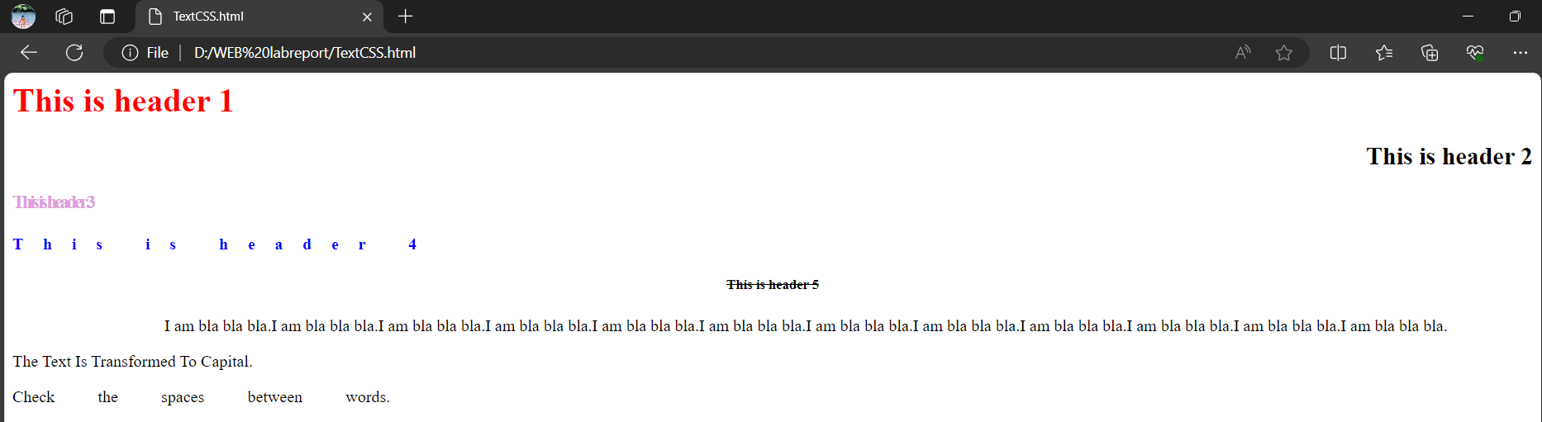

## /*Lab 11:CSS font properties */

<html>

<head>

<style type="text/css">

p {

    font-style: italic;

    font-variant: small-caps;

    font-weight: 900;

    font-size: 12px;

    font-family: Arial; }

    p.normal {font-variant: normal; color:green; font-family:Geneva}

</style>

</head>

<body>

    <p class="normal"> This is a paragraph 1</p>

    <p class="small"> This is a paragraph 2</p>

    <p>This is a paragraph 3</p>

</body>

</html>

## Output

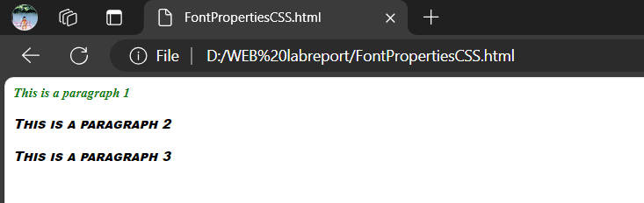

## /*Lab 12:CSS border properties */

<html>

    <head>

        <style type="text/css">

            p.dotted {border-style: dotted}

            p.dashed {border-style: dashed}

            p.solid {border-style: solid;}

            p.double {border-style: double}

            p.groove {border-style: groove}

            p.ridge {border-style: ridge}

            p.inset {border-style: inset}

            p.outset {border-style: outset}

            P{

                border-color: cornflowerblue;

                border-radius: 5px;

            }

        </style>

    </head>

    <body>

        <p>The "border-style" property is not recognized by Netscape 4.</p>

        <p>Netscape 6 supports all border styles.</p>

        <p class="dotted">A dotted border</p>

        <p class="dashed">A dashed border</p>

        <p class="solid">A solid border</p>

        <p class="double">A double border</p>

        <p class="groove">A groove border</p>

        <p class="ridge">A ridge border</p>

        <p class="inset">An inset border</p>

        <p class="outset">An outset border</p>

    </body>

</html>

## Output

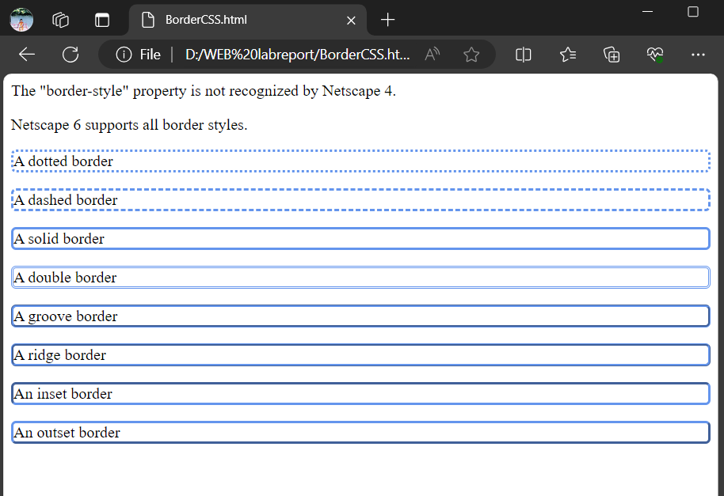

## /*Lab 13:CSS margin and padding*/

HTML File

<!DOCTYPE html>

<html lang="en">

<head>

    <title>Margin And Padding</title>

    <link rel="stylesheet" href="Style.css">

</head>

<body>

    <span class="s1">All margin(50px): Padding (5px)</span>

    <span class="s2">Left margin(70px): top, bottom Padding(5px) and left,right Padding (10px)</span>

    <span class="s3">margin top,bottom(150px), right,left(20px): no Padding</span>

</body>

</html>

CSS file

span {

    border: 1px solid;

    position: absolute;

}

.s1 {

    margin: 50px;

    padding: 5px;

}

.s2 {

    margin-left: 70px;

    padding: 5px 10px;

}

.s3 {

    margin: 150px 20px;

}

## Output

